React.js

Lab Book

Copyright © 2016 Capgemini. All rights reserved. No part of this publication shall be reproduced in any way, including but not limited to photocopy, photographic, magnetic, or other record, without the prior written permission of Capgemini.

Capgemini considers information included in this document to be Confidential and Proprietary.

Document Revision History

|  |  |  |  |
| --- | --- | --- | --- |
| Date | Revision No. | Author | **Summary of Changes** |
| 21-Mar-2016 | 0.1 | Karthik M | Initial Draft |
|  |  |  |  |
|  |  |  |  |
|  |  |  |  |

Table of Contents

Document Revision History 2

Table of Contents 3

Getting Started 4

Overview 4

Setup Checklist for React.js 4

Instructions 4

Learning More (Bibliography if applicable) 4

Lab 1. React.js Essentials 5

1.1: Creating Hello World React Page (By Transforming JSX to JS) 5

1.2: TODO-Assignment: Working with CSS Classes 7

1.3: TODO-Assignment 9

1.4: TODO-Assignment 10

1.5: TODO-Assignment 11

Appendices 12

Appendix A: Coding Best Practices 12

Appendix B: Table of Figures 13

Getting Started

## Overview

This lab book is a guided tour for learning React.js. It comprises solved examples and ‘To Do’ assignments. Follow the steps provided in the solved examples and work out the ‘To Do’ assignments given.

## Setup Checklist for React.js

Here is what is expected on your machine in order for the lab to work.

Minimum System Requirements

* Intel Pentium 90 or higher (P166 recommended)
* Microsoft Windows 7 or above.
* Memory: 2GB of RAM (1GB or more recommended)
* Google Chrome v45 or above

Please ensure that the following is done:

* A text editor like Notepad++, Notepad

## Instructions

* For all coding standards refer Appendix A. All lab assignments should refer coding standards.
* Create a directory by your name in drive <drive>. In this directory, create a subdirectory react_assign. For each lab exercise create a directory as lab <lab number>.
* You may also look up the on-line help provided in the <http://facebook.github.io/react/>.
* The faculty will introduce you to the editor to be used.

## Learning More (Bibliography if applicable)

* Apress Introduction to React by Cory Gackenheimer
* PACKT Publishing React.js Essentials by Artemij Fedosejev

1. React.js Essentials

|  |  |
| --- | --- |
| **Goals** | * Understand the process of creating a jQuery page and viewing it in a browser window. * Understanding Content Delivery Network (CDN) and using the hosted jQuery file from Google or Microsoft |
| **Time** | 20 minutes |

## 1.1: Creating Hello World React Page (By Transforming JSX to JS)

Create a web page to display the message ‘Hello World’.

Solution:

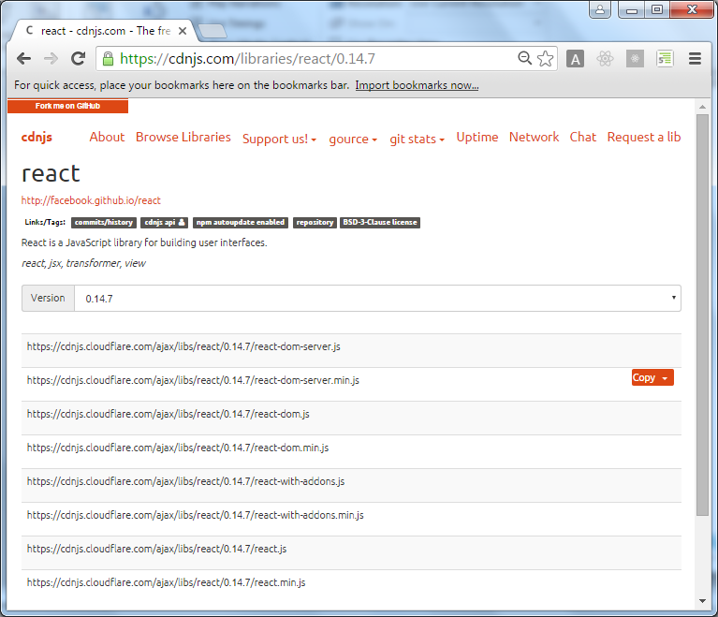**Step 1:** Download the latest React script (React v0.14.7) from https://cdnjs.com/libraries/react

Figure 1: cdnjs.com

**Step 2:** Create a folder named scripts under React-Lab-Solutions in C:\ or D:\ and place the scripts in it by downloading it from the following url as shown below .

**react.**js : https://cdnjs.cloudflare.com/ajax/libs/react/0.14.7/react.js

**react-dom.**js : https://cdnjs.cloudflare.com/ajax/libs/react/0.14.7/react-dom.js

**browser.**js : https://cdnjs.cloudflare.com/ajax/libs/babel-core/5.8.34/browser.js

**jquery.**js : https://cdnjs.cloudflare.com/ajax/libs/react/0.14.7/react.js

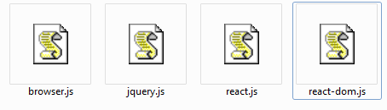

Figure Script to Download

**Step 3:** Open any text editor like notepad and type the following code and save it with .html extension in React-Lab-Solutions folder.

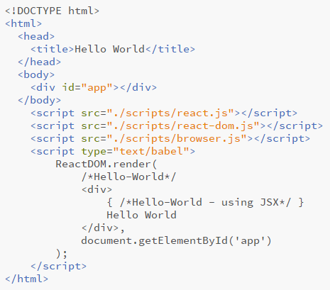

Figure 3: Save contents as an *.html* file

**Step 4:** Open the file which we have saved, in browser. Output will appear as shown in the following figure:

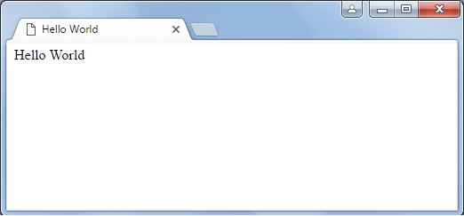

Figure 4: HelloWorld.html in a browser

## 1.2: TODO-Assignment: Working with CSS Classes

Create a React Webpage by referring the HTML Code given below and try to match the output as shown below.

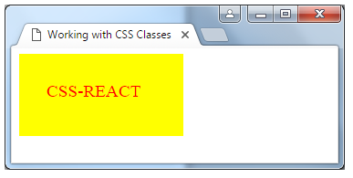

Figure TODO Assignment-Output

**Code for Reference :**

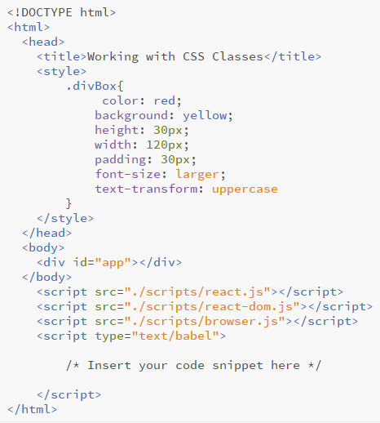

Figure TODO-Assignment-Code Snippet



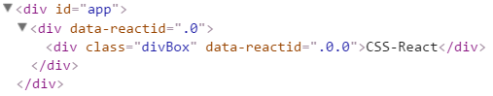

Use **className** instead of **class** CSS Attribute for the above rendered code.

## 1.3: TODO-Assignment: Creating a React Component

Create a NumberFinder React component which has a prop number to accept number types. The component should render a div with either the text "Odd Number" or "Even Number" depending on the value passed to the prop.

Code for Reference:

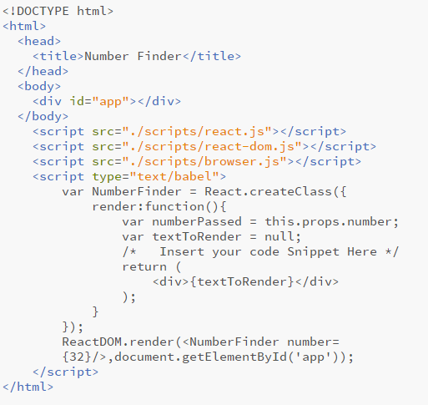

Figure TODO-Assignment-Code Snippet

## 1.4: TODO-Assignment: Nested Component

Create a nested React component Parent and Child. Add a click handler to the button placed in child Component; so that when it is clicked call the function sayHi from the Parent Component

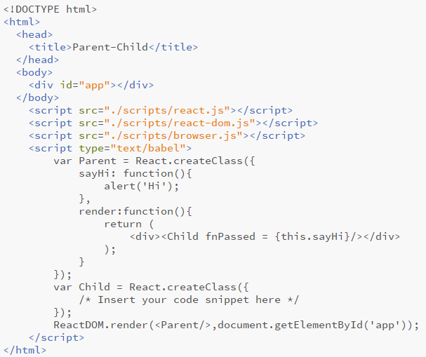Code for Reference:

Figure TODO-Assignment Code Snippet

## 1.5: TODO-Assignment: Working with State and Ref

Create a nested React component Parent and Child. Add a click handler to the button placed in child Component; so that when it is clicked call the function sayHi from the Parent Component

Code for Reference:

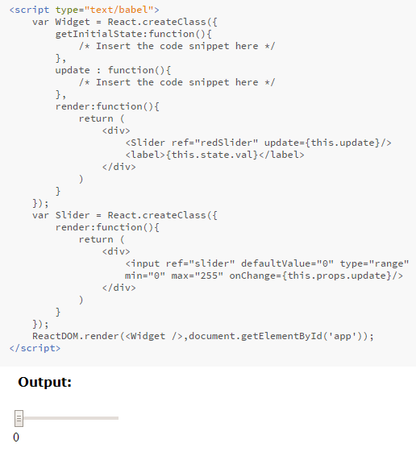

Figure TODO-Assignment-code-snippet

Appendices

## Appendix A: Coding Best Practices

## Appendix B: Table of Figures

Figure 1: cdnjs.com 5

Figure 2: React Scripts Folder **Error! Bookmark not defined.**

Figure 3: Save contents as an *.html* file 6

Figure 4: HelloWorld.html in a browser 7

Figure 5 TODO Assignment-Output 7

Figure 6 TODO-Assignment-Code Snippet 8

Figure 7 TODO-Assignment-Code Snippet 9

Figure 8 TODO-Assignment Code Snippet 10

Figure 9 TODO Assignment code snippet 11